NEMBE-IBE USA
TABLE 4a
RECIPIENTS OF 2013/2014 SECONDARY & UNIVERSITY SCHOLARSHIP AWARDS
Sheet 1 of 2
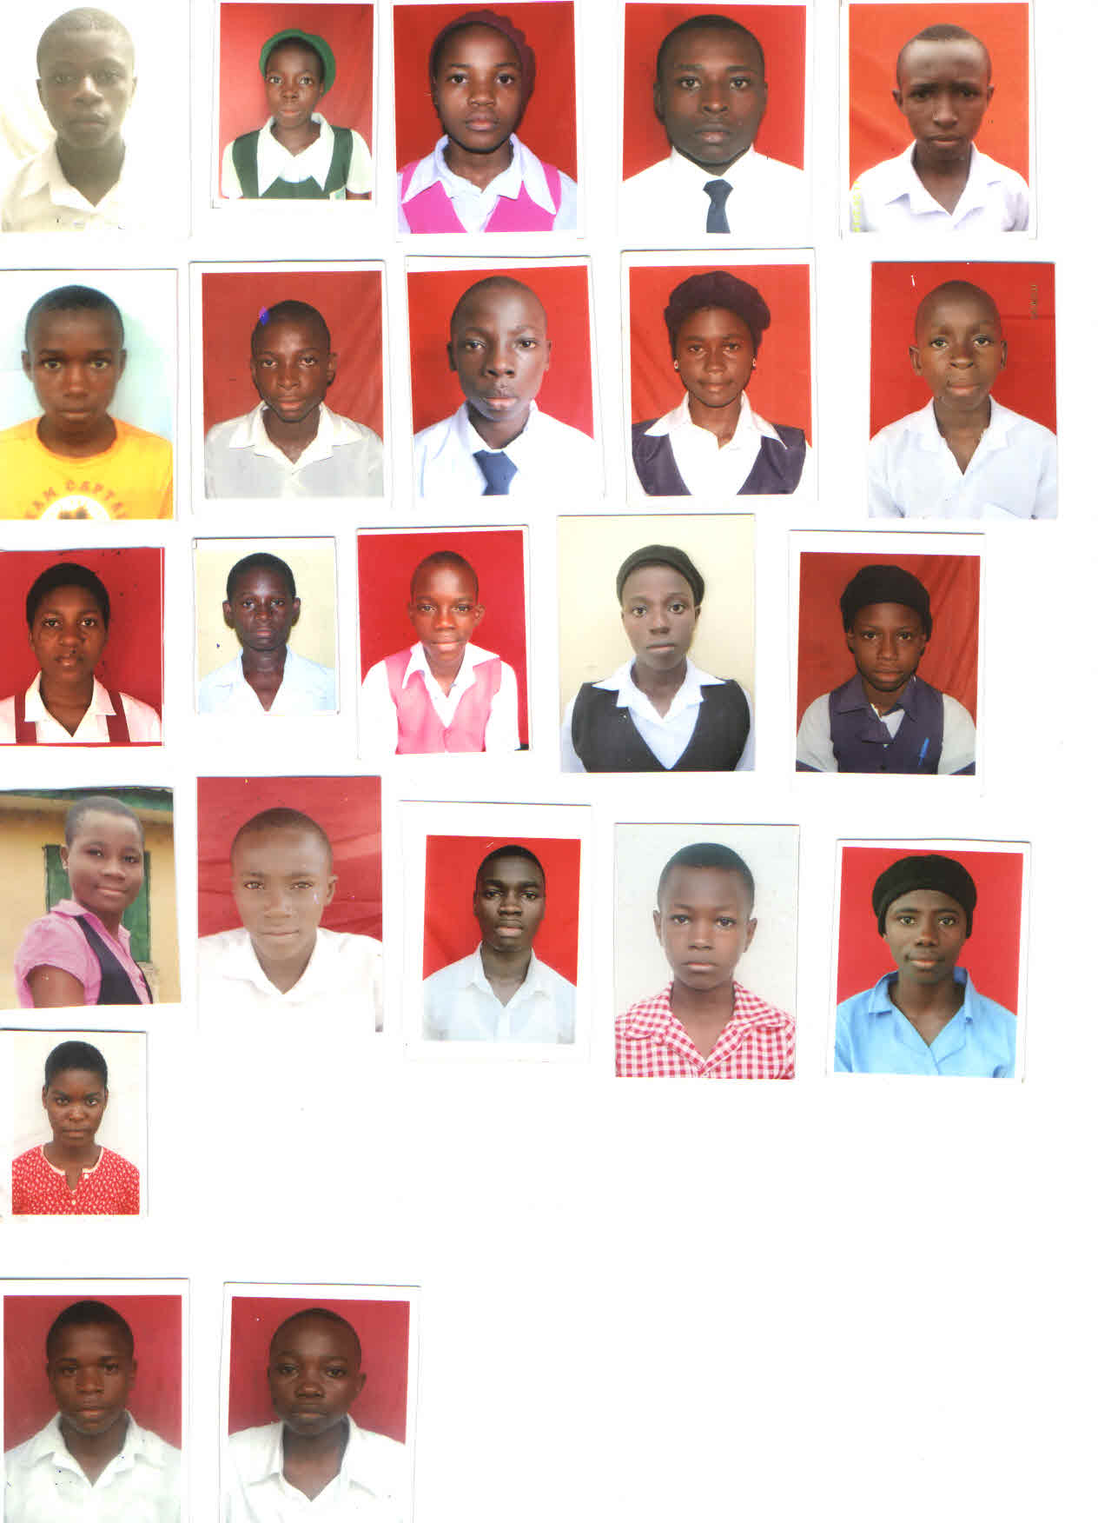  LOKO Negimote (SS2)  NNGS, Nembe (Ogbolomabiri) | SIMEON Ayebatari (SS )  NNGS, Nembe (Ogbolomabiri)  (UNKNOWN) | ALLEN Wilson (SS3)  NNGS, Nembe (Ogbolomabiri) | 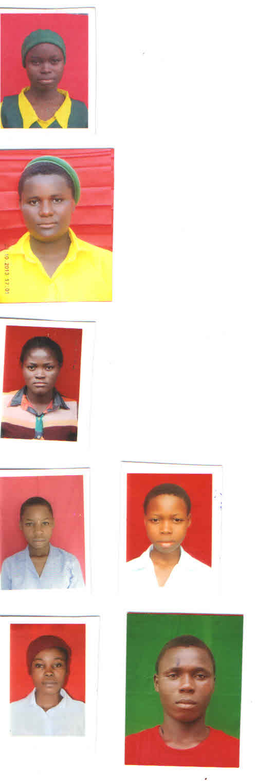  FAGHA Ebikumo (  BJSS, Obioku
OMIEKUMA Baranaye  BJSS, Obioku  (PENDING) | LANDER Ebiye (SS2)  GSS, Okpoama | 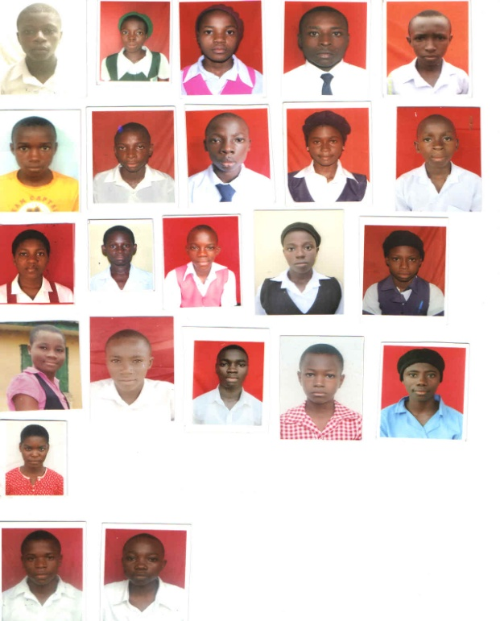  OTIETE Tariyalayefa  GSS, Okpoama | 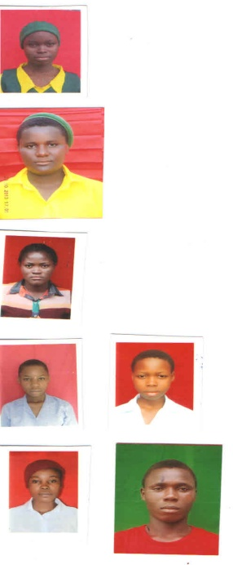  GEORGE Wariebimiekuma  CSS, Minibie
PARKE Dorcas  CSS, Minibie | WARIBUGO Grace (SS2)  CSS, Beletiema | ABILI Redemption (SS3)  CSS, Beletiema | GABRIEL Meremubio (JS2)  BJSS, Twon-Brass
OBOTE Joseph (SS1)  BJSS, Twon-Brass | THEOPHILUS Blessing (SS2)  BJGGSS, Nembe (Bassambiri) | OZU Gold (JSS3)  BJGGSS, Nembe (Bassamnbiri) | DIETE Tony (SS2)  CBSS, Nembe Bassambiri
OGARA Miete (SS2)  CBSS, Nembe Bassambiri | AMAKIRI Blessing (SS 2)  CBSS, Nembe Bassambiri | 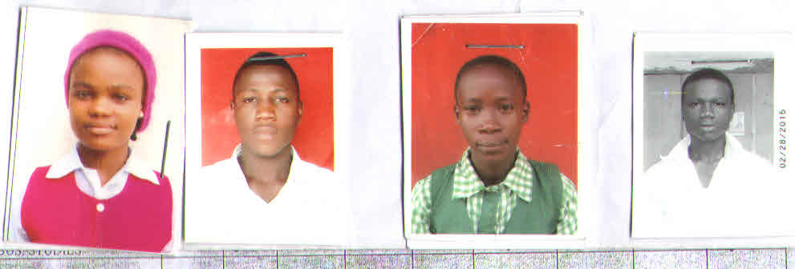  APIRI Blessing  BJSS, Otomoama-Oluasiri  PENDING | ATEI Animiworio  BJSS, Otomoama-Oluasiri  PENDING

